

**British Handball Association**

**Safeguarding and Protecting Young People Policy and Procedure**

*Document Owner: Joanna Cook*

*Document approved by: BHA Board. Guided by CPSU*

*Date Policy approved: [insert date]*

*Next review Date: [insert date]*

## **Introduction**

The British Handball Association (BHA) is committed to providing a safe environment for everyone to participate in our organisation and its activities. This policy and procedure must be followed in any circumstances where there is concern over a child or young person. Safeguarding in sport helps ensure all children participating in sport have a positive experience.

This policy outlines the BHA’s commitment to safeguarding as well as what we mean by the risks that may occur to a child or young person. The procedure details the steps to be taken in responding to any concern that an child/young person involved in the BHA, or its activities, is at risk of or is experiencing harm. This can arise from a child’s home life or from school, and not necessarily in their sporting environment, although this may be where it is noticed.

If a concern is raised to the BHA in relation to a club or home nation then steps will be taken to hand the case to the relevant safeguarding leads, with the agreement of those raising the concern. Should any of the parties wish for the BHA to continue their involvement in the case, this can be made possible with a case management setting.

**BHA’s Commitment and Safeguarding Statement**

The BHA are committed to providing an environment in which all athletes can participate in its activities and have a safe and positive experience, whether it is in training, competition, work or volunteering.

The sport of handball in all its disciplines is constantly changing and evolving. This Safeguarding & Protecting Young People Policy and Procedure has been designed to both inform and guide those within our sport on all aspects of safeguarding.

The BHA believes that all participants, staff and volunteers should feel safe while participating in handball. We are committed to creating and maintaining a positive environment where all concerns will be listened to, acted on appropriately and all participants are treated with respect.

**Responsibility to safeguard children**

The Children Acts 1989 and 2004 as amended by the Children and Social Work Act 2017 and the Government document “Working Together to Safeguard Children 2023” are clear that safeguarding children is the responsibility of all, including those who are employed or volunteer with children in whatever capacity. It is the organisations’ responsibility, through safe recruitment practice, to ensure that those who are deemed to be unsuitable to work with children are not allowed to do so in our sports. The Disclosure and Barring Service (DBS) is an important, but not sole, part of safe recruitment.

In order to achieve this, the BHA will:

Adopt and implement the BHA Safeguarding guidance in this policy, and make it publicly known to all, to be read, where relevant, in conjunction with the relevant Home Nation Child Safeguarding/Protection Policy and Procedures.

Recognise that all athletes participating in a BHA funded activity regardless of age, class, sexual orientation, gender, religion or disability have a right to a safe environment and to be protected from harm.

Ensure all those who are involved in providing BHA funded activities directly with athletes provide a safe and positive environment, and are aware of their roles and responsibilities in respect to safeguarding.

Appoint a person to take the lead responsibility in ensuring all safeguarding practices, policies and guidance are adhered to in full and ensures succession planning. This appointed person is: Joanna Cook (performance lead) (contact details are at the end of this document).

Ensure that all those recruited to work directly with athletes have been recruited in line with best practice and in accordance with the requirements of the Disclosure and Barring Service (DBS) in England and Wales and the Protection of Vulnerable Groups Scheme (PVG) in Scotland.

Ensure that all those recruited to work directly with athletes have the opportunity to undertake relevant BHA/Home Nation approved child safeguarding training and adhere in full to the safeguarding guidance and policies.

Ensure appropriate action is taken in the event of incidents/concerns of abuse and support provided to the individual/s who raise or disclose a concern. Ensuring it is reported in line with best practice and dealt with appropriately.

Ensure that confidential, detailed and accurate records of all safeguarding concerns are maintained and securely stored.

Ensure that confidentiality is maintained, where appropriate and act in the best interests of the athlete and / or sport personnel.

This Policy and Procedure is mandatory for everyone involved with the BHA (through signing up to the various policies annually - this will be through a short online BHA form). Failure to comply as outlined in the Code of Conducts will be addressed without delay, and may ultimately lead to dismissal or exclusion with the BHA.

**Definitions of abuse**

* **Physical** - when someone hurts or harms a child or young person on purpose. In handball this could include concerns about children physically harmed at home, or an assault in the handball environment. It could also include overtraining or inappropriate training for a person’s agenda development. For more information see the [**NSPCC website**](https://www.nspcc.org.uk/).
* **Sexual** - when a child or young person is forced or tricked into sexual activities. This could be through contact or no contact. In handball this could include concerns outside the club, over social media, e.g. indecent images, or grooming of a young person by a person in a position of responsibility. For more information see the NSPCC website.
* **Emotional/Psychological/Mental/ & bullying** - any type of abuse that involves the continual emotional mistreatment of a child. This can also be a symptom of the other types of abuse. It's sometimes called psychological abuse. In handball, this could include abusive language towards young people from a parent, peer, or a coach deliberately trying to scare, humiliate, isolate or ignore a child, e.g. a coach may bully to win at all costs. For more information see the NSPCC website.
* **Neglect and acts of omission** - the ongoing failure to meet a child's basic needs and the most common form of child abuse. In handball, there could be concerns about malnourishment or cleanliness in a child’s home, or young people not being given water during training or not being allowed to go to the toilet.

**Further definitions**

* **Position of trust -** is a legal term that refers to an adult who is “regularly involved in caring for, training, supervising or being in sole charge of children and young people”
* **Child or young person –** Across the home nations, a child is anyone below the age of 18 years. These terms will be used interchangeably throughout this document.
* **Safeguarding –** those processes to ensure that a child remains safe within handball.
* **Grooming** - grooming is when someone builds a relationship, trust and emotional connection with a child or young person so they can manipulate, exploit and abuse them.
* **Child protection** – the processes to respond to concerns about a child.
* **Statutory agencies** – this includes organisations who have a statutory/legal role in responding to concerns about children. They include:

– Children’s Services (also called Children’s Social Care or Social Services) who work to protect children from harm

– Police who address concerns about criminal behaviour.

– (Local Authority) Designated Officers who address concerns about those in positions of responsibility.

- [NSPCC](https://www.nspcc.org.uk) - a registered charity to prevent abuse, help rebuild children’s lives, and support families.

**BHA’s Reporting Procedure**

It is important to always remember that for all members, volunteers and staff within the BHA, concerns about children and young people (this includes poor practice ie; breach of Code of Conduct (add link) such as being alone with young person at the end of a session as parents are running late to collect them) should be reported. It is not the responsibility of individuals to determine whether abuse has taken place, but it their responsibility to follow these procedures to report concerns.

Concerns can come from a variety of sources; observations of changes in behaviour, observations of an incident, reports by the young person themselves, or other young people about a concern, allegations made about staff, volunteers, parents or guardian, or other athletes.

**In an emergency**

* When you believe a child has been harmed or may be at immediate risk of harm then immediate contact should be made with the police, social services, NSPCC Child Protection Helpline or other agencies as appropriate.
* Take the name and contact details of the person you have spoken to and the incident/referral reference number (if applicable) so you have a record.
* Complete the Safeguarding Children’s Incident Form (see appendix), and report this to the the Safeguarding Lead as soon as possible e.g. next working day.
* Parents and guardians of the child will be advised of the actions taken and involved in subsequent actions unless this places the child in immediate and significant harm.

**Stage 1 – Reacting in a timely and appropriate manner.**

If a child or adult shares a concern or allegation with you:

* Stay calm.
* Reassure the person reporting their concerns that they have done the right thing in telling you.

• Listen carefully to what is being said.

* Ensure you don’t show upset, disgust or disbelief at what is being said.
* Be honest and explain that you cannot keep what they are saying a secret and never promise to do so.

• Keep an open mind and don’t make assumptions or judgements.

• Ask open questions only if you need to clarify what is being said.

* Reassure the person you take their concerns seriously and tell them the actions that you will, or will not be taking.
* Write down what has been said as soon as possible after or during the conversation as appropriate. The Safeguarding Children’s Incident form can be used to record the information.
* Sign and date the form and any other paperwork referring to the concern as this could be used at a later date in criminal or care proceedings.
* Report the concern to the Safeguarding Lead at the BHA.

**Stage 2 – Recording**

The BHA provides a Safeguarding Children’s Incident Form to use to record information. This can be found in the appendix of this document.

Your report should ideally include:

• Name, address and date of birth of the child.

• Name, address and contact details of the parent/guardian.

• Is the parent/guardian aware of the referral?

* Full details of the referral. Ensure the referral details are recorded verbatim i.e. always use the referrer’s own words.
* Details of who the allegation is about. If possible their full name, date of birth, address, relationship with the child concerned and their relationship or position with the organisation (if any).
* Details of any injuries, marks or bruising on the child that are visible to you. A body map template can be used.

• Details of any witnesses.

• Any other relevant information.

• Provide your contact details and sign and date your report.

**Stage 3 – Reporting**

It is the duty of everyone involved in our sports to report potential child safeguarding concerns in order to protect children, but it is only for the professionals to decide whether or not abuse has taken place.

Advice and guidance should always be taken from the safeguarding leads, various organisations like the NSPCC/CPSU (see further information below for details), or by contacting the police directly.

Parents and guardians of the child should be advised of the actions taken only if they are

not implicated/involved in the concern. Please note a parent/guardian cannot make the decision as to whether a safeguarding concern is disclosed to a statutory agency.

If you are not satisfied with the response of a statutory agency when making a referral please contact the Safeguarding Lead. They will support you to follow up or escalate your concerns with the agency concerned.

If the child is not considered to be at immediate risk of harm, contact should be made with the Safeguarding Lead with full details of the concern as soon as possible e.g. the next working day.

The Safeguarding Lead will hold a record of every concern securely, and must always be informed of an incident or concern, regardless of the situation.

**Next Steps for the Safeguarding Lead**

1. Ensure any **immediate actions** necessary to safeguard anyone at risk have been taken.   
     
   If the risk is said to be due to the behaviour of an employee or other person involved in the organisation/activities use the relevant procedures (e.g. breach of code of conduct, breach of contract, disciplinary or grievance procedures) to prevent that person making contact with the child/young person being harmed. It may require the employee/volunteer to be suspended from activity within the BHA whilst the matter is investigated to assess the risks. This could be a wider agreement from the Home Nations that the suspension is across all handball activity in the UK.
2. If you have been sent a **Safeguarding Children’s Incident Form,** check that you can understand what is written and that all the necessary parts have been completed.  
     
   If you are being contacted directly by a member of staff or a volunteer, request that they complete a Safeguarding Children’s Incident Form if they have not already done so (see Appendix) as soon as possible.
3. Inform, reassure, and advise the **person making the report** e.g. what to do/what not to do. Explain what will happen next. Reinforce the need for confidentiality.
4. Consider what is known about the situation, what the risks are and who is involved. Does further information need to be gathered?
5. Ensure that individuals (victim and alleged perpetrator) relevant to the report know about the process and what will happen next (see flowcharts below).
6. Consult and Decide - In the first instance the Safeguarding lead will look at the case. If required, consultation with Case Management Group*, and with the Local Authority/the Police, to decide which of the following actions need to be taken.

* Contact the police (where the crime took place)
* Make a referral/report to a statutory agency
* Use policies and procedures to stop harm within the organisation

1. Convene a **Case Management Group meeting** to coordinate actions internally to your organisation:

* share information about what has happened with those within the BHA who have a role in safeguarding the child.
* share the form.
* share any actions being taken by the Police/Local Authority.
* agree who will coordinate between the BHA and other agencies.
* decide what actions the BHA will take.
* Coordinate action by the BHA.

1. The Case Management Group meeting must be **recorded** so that decision making is transparent, and actions agreed are followed. **Follow up meetings** should be held as necessary until the actions needed are complete.
2. Ensure **records are complete and stored securely**. Collate monitoring information, including feedback from the person who was at risk of harm and **report to senior management team/ the Board as requested**.

*A Case Management Group will be formed of a small number of individuals with identified skills, knowledge and experience and include at least one member with independent child protection expertise. Key individuals will be the safeguarding lead, an independent and/or a representative from the safeguarding teams within the from handball home nations. Membership will be based on the following CPSU guidelines: https://thecpsu.org.uk/media/2507/case-man-group-membership.pdf

**Flowcharts showing the procedure taken dependent on the situation**

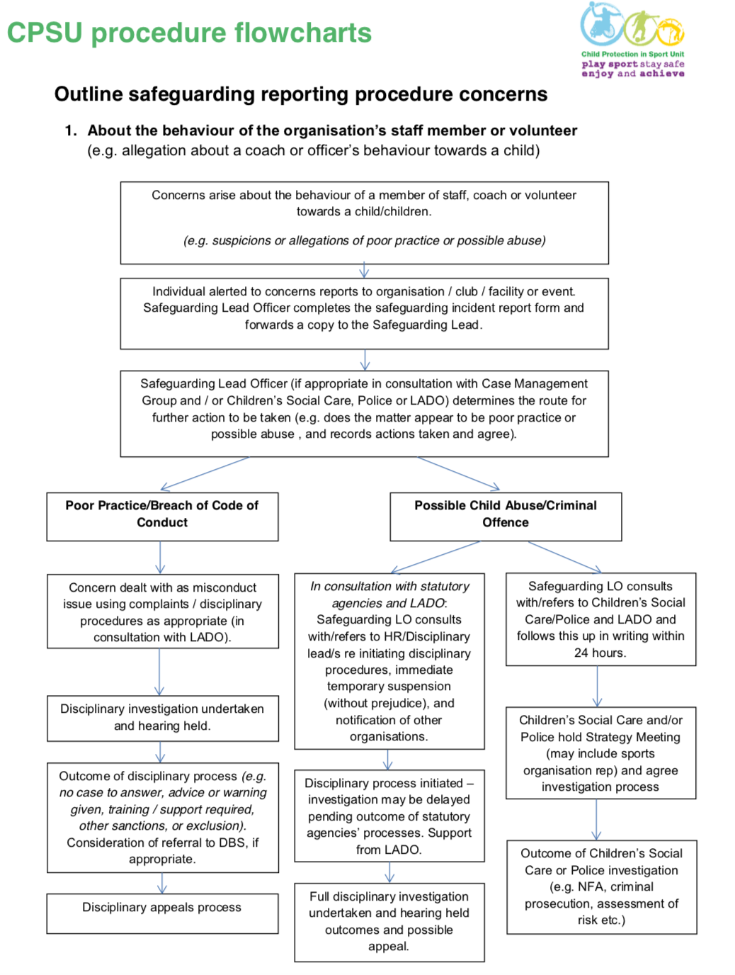

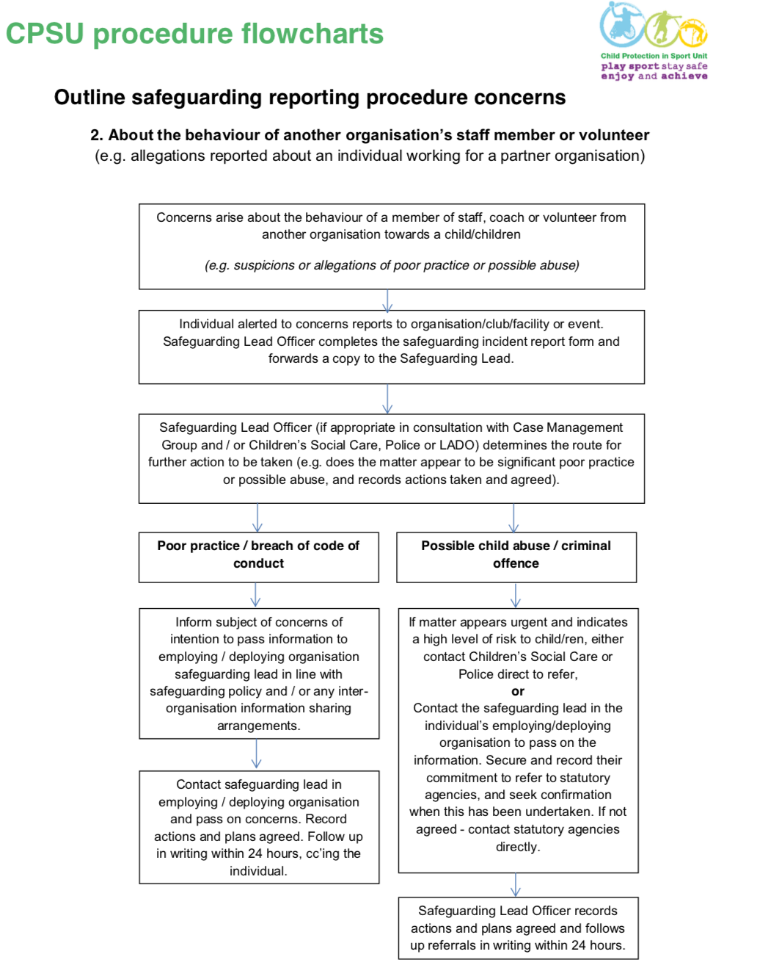

## CPSU Safeguarding Outside of sport flowchart.png

## **Further Information and Useful Contacts**

Policies, procedures and supporting information are available on the BHA website: <https://www.britishhandball.com>

**Safeguarding Lead:**

Joanna Cook, jcook@britishvolleyball.org

**Local Authority Safeguarding Adults Lead**

Dependent on your local authority, please use their website to find out further information

**Local Police Contact**

Dependent on your local authority, please use their website to find out further information

England Handball- [safeguarding@englandhandball.com](mailto:safeguarding@englandhandball.com)

Scottish Handball - [childprotection@scottishhandball.com](mailto:childprotection@scottishhandball.com)

NSPCC Child Protection in Sport Unit

v 0116 366 5580

a cpsu@nspcc.org.uk

NSPCC Helpline

v 0808 800 5000

B nspcc.org.uk

Childline

v 0800 1111

B [childline.org.uk](http://childline.org.uk)

For more information on the governments safeguarding children publication please refer to the full document at [gov.uk/government/publications/working-together-to-safeguard-children--2](http://gov.uk/government/publications/working-together-to-safeguard-children--2)

Glossary of other terms

BHA British Handball Association

CMG Case Management Group

CPSU Child Protection in Sport Unit

DBS Disclosure and Barring Service

GDPR General Data Protection Regulation

LADO (aka DO) Local Authority Designated Officer (England only)

NSPCC National Society for the Prevention of Cruelty to Children

### Appendix 1 - Safeguarding Children’s Incident Form

To be completed as fully as possible if you have concerns regarding a child or young person.

If it is safe to do so, it is important to inform the adult about your concerns and that you have a duty to pass the information onto the safeguarding lead. The Safeguarding Lead will then look at the information and start to plan a course of action.

|  |  |  |
| --- | --- | --- |
| Section 1 – Details of child/young person (of whom there is concern about) | | |
| Name of child/young person |  | |
| Date of Birth/ Age |  | |
| Gender at birth |  | |
| Parent/carer’s name |  | |
| Address |  | |
| Contact number(s) |  | |
| Disability (if any) |  | |
| Consent to share information with emergency contact? |  | |
| Section 2 – Details of the person completing this form/ Your details | | |
| Name |  | |
| Contact phone number(s) |  | |
| Email address |  | |
| Line manager or alternative  contact |  | |
| Name of organisation / club |  | |
| Your Role in organisation |  | |
| Are you reporting your concerns or those passed on by somebody else | | |
| If yes, please provide their names and contact details. | | |
| Section 3 – Details of concern | | |
| Please describe the concerns/observations. Include dates, times, venues and any other specific information | | |
| Section 4 – Details of the person thought to be causing harm (if known) | | |
| Name |  | |
| Address |  | |
| Date of Birth/Age |  | |
| Relationship/connection to adult |  | |
| Role in organisation |  | |
| Do they have contact with others that could be at risk in another capacity? E.g. in their work/family/as a volunteer |  | |
| Section 5 - Have you spoken to the young person? Please give as much detail of what was said and when | | |
|  | | |
| Section 6 – Have you spoken to the parent/carer of the young person involved? If so, please give details of what was said and when. | | |
| Discussion would put the adult or others at risk. Please explain: | | |
| Section 7 – What action have you taken so far? | | |
|  | | |
| Section 9: Other agencies contacted | | Who contacted/reference number/contact details/advice gained/action being taken |
| Police / Ambulance | |  |
| British Handball Association | |  |
| Children’s social care | |  |
| Other e.g. NSPCC – please state who and why: | | |
| Section 10: Contact with others | | |
| Who else has been informed of this issue? – and what was the reason for information sharing | | |
| Completed Form copied to Safeguarding Lead; Date and time | | |
| Signed: | | |
| Date: | | |

Remember to maintain confidentiality. Do not discuss this incident with anyone other than those who need to know. This form should be returned to the Safeguarding Lead